**Week 6**

**4.ReactJS – HOL**

**FILE STRUCTURE  
  
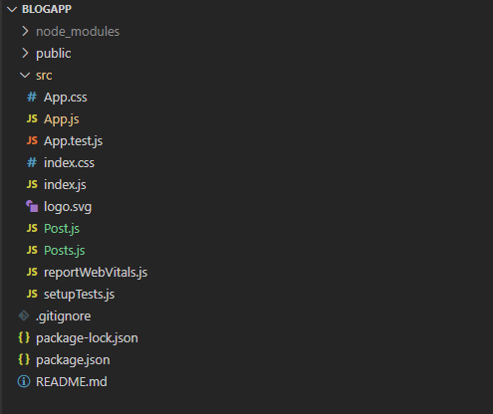  
  
CODE**

*C:\Users\User\Desktop\blogapp\src\Post.js*

class Post {

    constructor (id, title, body){

        this.id = id;

        this.title = title;

        this.body = body;

    }

}

export default Post;

*C:\Users\User\Desktop\blogapp\src\Posts.js*

import React from 'react';

class Posts extends React.Component {

  constructor(props) {

    super(props);

    this.state = {

      posts: [],

    };

  }

  loadPosts() {

    fetch('https://jsonplaceholder.typicode.com/posts')

      .then((response) => response.json())

      .then((data) => {

        this.setState({ posts: data });

      })

      .catch((error) => {

        alert("Error loading posts: " + error.message);

      });

  }

  componentDidMount() {

    this.loadPosts();

  }

  render() {

    return (

      <div>

        <h2>Blog Posts</h2>

        {this.state.posts.map((post) => (

          <div key={post.id} style={{ marginBottom: '20px' }}>

            <h3>{post.title}</h3>

            <p>{post.body}</p>

          </div>

        ))}

      </div>

    );

  }

  componentDidCatch(error, info) {

    alert("An error occurred in the Posts component: " + error);

  }

}

export default Posts;

**OUTPUT**

